- Design and implement a simple frame-based knowledge representation system in Prolog using the concept of classes, slots, inheritance, and instances.Your system should allow defining classes with default attributes (slots), creating instances of classes, overriding slot values for specific instances, and retrieving slot values with inheritance.

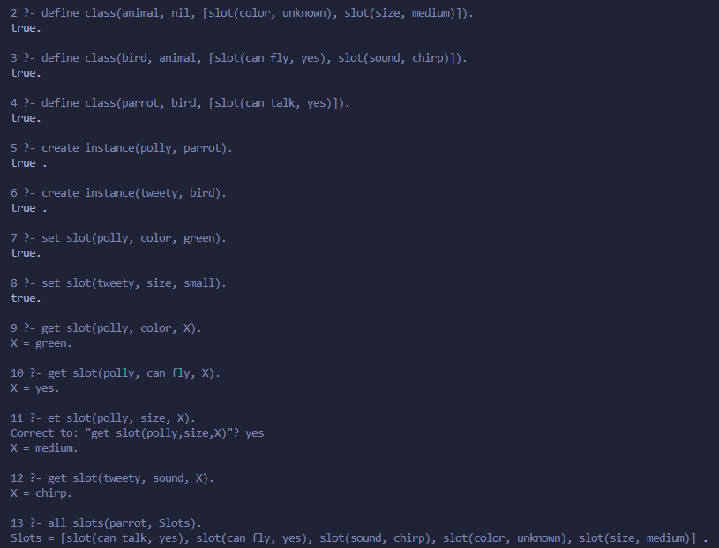

- Represent and reason about a semantic network in Prolog using graph concepts. Your program will store entities, their relationships, and allow reasoning through inheritance by traversing the graph.

